Roadmap Banana content for Germany region

I understand from our discussions that this you propose a kind of introduction for German users that would fill the regional section for German on the Banana webstite.

In the following, I propose a structure of what I think is useful for German users to get as information in order to get quick started with Banana in a DATEV/Steuerberater conform way.

Chapters are structured like a tutorial. It takes into account that the mere functionalities of Banana are well described in the documentation so it won’t repeat what is in there. The focus is on how to get done the whole accounting process. I assume that a typical user has some basic accounting knowledge.

Structure of the German guide

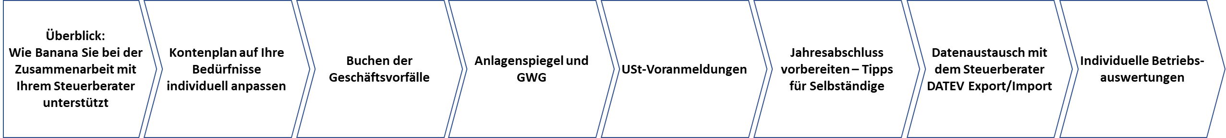

**Overview of how to best work with Banana as a German based user**

* Explain tutorial structure of this guide
* Most important Banana advantages as compared to traditional accounting software
* Advantages in using Banana AND cooperating with a Steuerberater
* Reference to possibility to use data in a DATEV compatible way and to transfer data to ELSTER

**Adapt Kontenpläne to personal needs**

* Available Kontenpläne on Banana
* Which tax relevant business are you corresponding to German legislation? What kind of Kontenplan do you need?
* Special SKR03Kontenpläne for cooperation with a Steuerberater (differences to other Kontenpläne provided in Banana)
* EÜR systematics, calculation of Betrieblicher Gewinn/ Steuerlicher Gewinn
* Adapt Kontenplan to personal needs from Master Kontenplan
* How to separate business/ private in a combined account plan in a DATEV/Steuerberater-compatible way

**Booking accounting transactions**

* The most important groups and accounts
* VAT codes, automatic accounts, and how they belong to certain expense and revenue accounts
* Import banking data, recommended cross checks and error avoidance
* A Collection of most important accounting records for German businesses, to be continued by request or user feedback, like booking of tax relevant particularities (eg Telefon, Bewirtung, Privatanteile etc.)
* Useful references to external sources for further information on tax and DATEV conform booking of transaction cases
* Booking of private transactions, usage of private accounts

**Assets and Amortisations**

* Basic functionalities of the Banana Anlagen-Tabelle, Rough introduction to how it works and how to get started from the scratch
* Structure of the Anlagenspiegel-Table for EÜR and How to adapt it to personal need
* How to generate which amortization bookings and how to transfer the asset-table from year to year
* Some basics about German legislation concerning Amortisations (GWG, Pool- und Einzelabschreibung), typical amortization periods

**Umsatzsteuer-Voranmeldungen**

* Banana App? (or table?) to generate the Elster-Kennziffern, transfer to Elster manually or with interface?
* Reference to Banana standard VAT reporting (MwSt Zusammenfassung etc.)
* and more things depending on how exactly Banana will provide the Elster Kennziffern or interface (see Roadmap Elster)

**Preparing the annual financial statement and some tipps for entrepreneurs**

* How a DATEV conform tax report looks like, which data it provides, and how it is related to the forms
* How to generate with Banana the reports and print-outs that correspond to these tax reports
* Some tax relevant end-of-year bookings for KFZ-Nutzung, Arbeitszimmer, Vorsorgeaufwendungen etc.
* If available: How to generate the Elster Kennziffern, transfer data to Elster
* Reference to external sources for relevant tax legislation for entrepreneurs

**Data exchange with tax advisor**

* Datev export file and reimport file. Learning from experience and exchange
* Issues to clarify with the Steuerberater concerning account plan, bookings, amortisations etc.
* Avoiding errors in the Kontenplan concerning Datev- and Elster-relevant information when changing or adding accounts

**Individual business reports**

* Summary and reference to Banana functionalities Kunden/ Lieferanten, Profit/Cost-Centers, Segmente
* Budgeting and graphical representations
* Advantages to standard DATEV reports, possibilities
* Examples, use cases for different business types like Consulting, Engineering, Training, Production, Event-Management etc.

Estimated workload

15-20 working days